In Chrome, first click on the little puzzle piece in the URL bar and click manage:

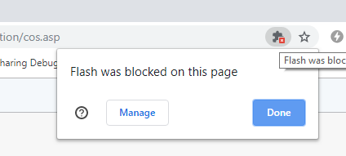

Then set the “Block sites…” option to “Ask first”:

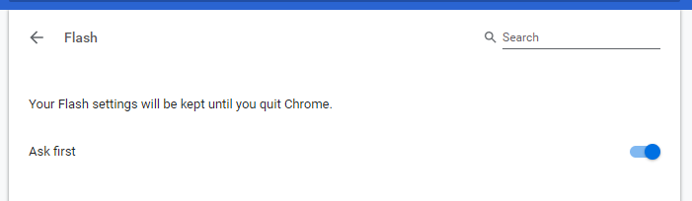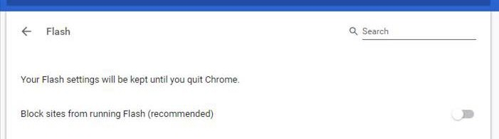

Close the window and then try the link again: <http://go.cos.edu/onlineorientation/cos.asp>

You should then get a screen that says “Click to enable Flash Player”. Do that:

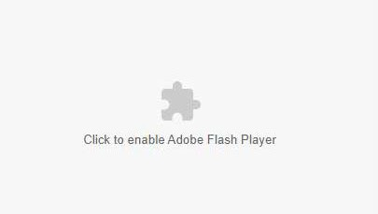

Say “Allow” to the next warning:

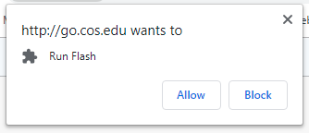

It should then work: