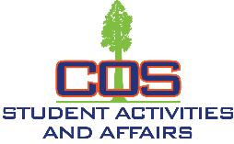
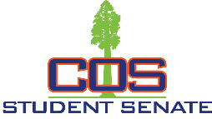
STUDENT ACTIVITIES & AFFAIRS / STUDENT SENATE
915 S. Mooney Blvd., Visalia CA 93277 - Giant Forest Bldg, Rm123 - (559) 730-3736

Student Senate Meeting Agenda
September 6, 2022 11:10 am Board Room – Sequoia Bldg
If you would like to attend, please contact Wil Hobbs, williamh@cos.edu or Marilyn Fimbres, marilynf@cos.edu

- CALL MEETING TO ORDER - PLEDGE OF ALLEGIANCE
- ROLL CALL
- APPROVAL OF THE AGENDA (General Consent)
- APPROVAL OF THE MINUTES
- PUBLIC COMMENT
- ADVISORS REPORT
  - ALL: Peer Mentoring quiz due Sep 13
  - Music discussion in Canvas
  - T-shirts at 8am tomorrow
- EXECUTIVE BOARD REPORTS - None
- COLLEGE COMMITTEE REPORTS – Signup today
- OLD BUSINESS
  - Club Rush – “all hands on deck”
  - Giant Astronomy Club vote
  - 2022-23 Budget vote
  - Event committee co-chairs
    - Oct 5-6 / Vote-Constitution (Carrie, Hannah, )
    - Oct 31 / Food Drive-Costume ( )
    - Nov 10 / Veterans (Michael, Luis, Sheila)
    - Dec 7-8 / Toy Drive-Ugly Sweater ( )
- NEW BUSINESS
  - College committees – Signup
  - Ag Council – Tulare – 1st Thursday at Noon
- ANNOUNCEMENTS
  - Complete signups before leaving
- ADJOURNMENT

SAA2022-23/SS – Agenda Page 1 of 1

