

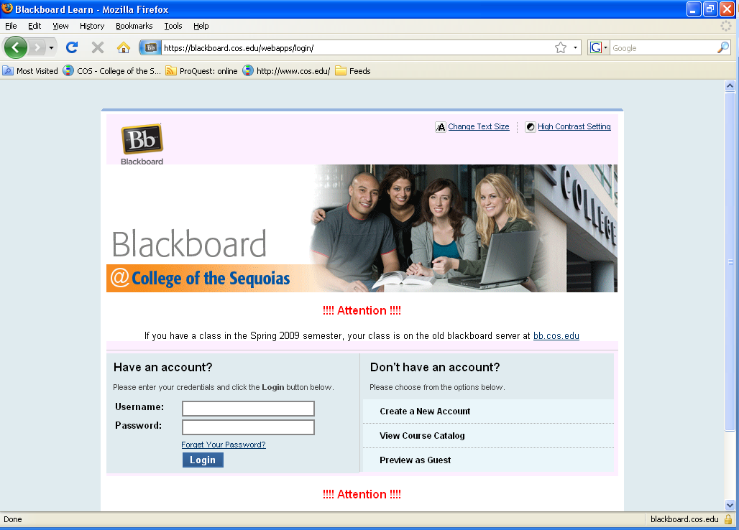

Student Quick Guide to Using Blackboard @ College of the Sequoias (Blackboard Learn™)

Username and Password
Your Blackboard username is your 8-digit COS student ID number (without the @ sign). You can find your new Bb password in Banner Web on the Financial Aid page. Click on View Student Email/Blackboard Information (see below).
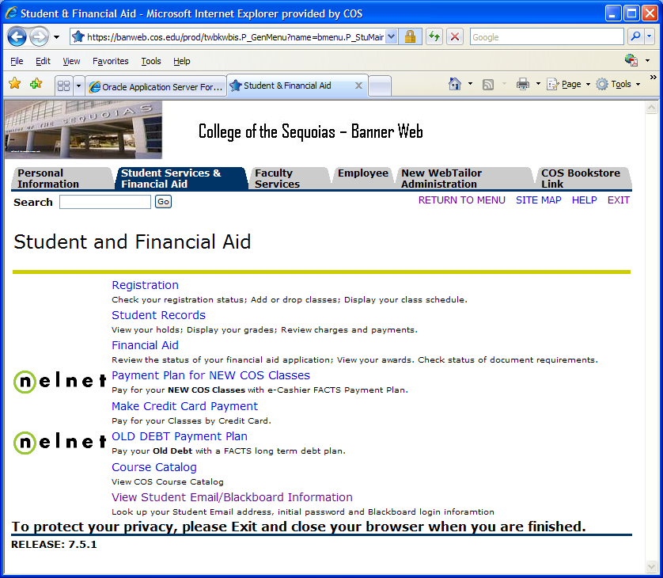

Logging In
In your browser (Mozilla Firefox Is Recommended), enter the URL: http://blackboard.cos.edu. On the login page, enter your Username and Password.
Click Login.

Change your Password
After you log in to Blackboard the first time, please change your password. Go to My Blackboard>Personal Information>Change Password. Please keep your password secure.
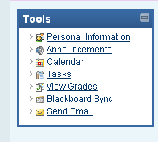
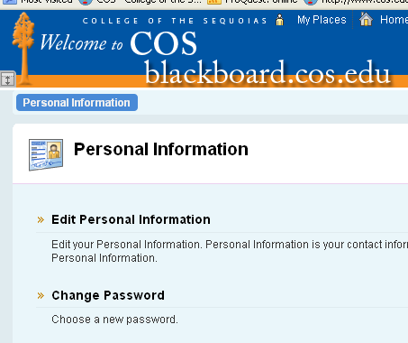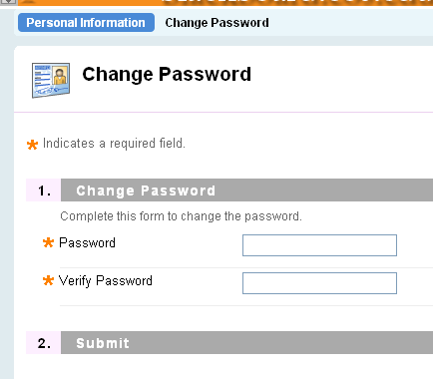

Accessing Course Materials

After you log in, you will arrive at your My Blackboard page. Click on the title of your class on the right side of the screen to “enter” the class. When you enter your class, you will see the course menu on the left side of your screen. From the menu, you can link to the information and materials that your instructor has provided for you. Additionally, you can link to course tools to check your grades, send an email, engage in an online discussion, or access the user manual. Every instructor organizes his or her class differently. Take some time to navigate to the various menu areas to learn how the class is organized.

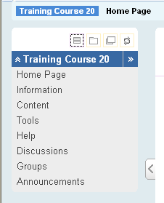

Checking Your Email

All COS students are given a free COS email account (yourfirstname.yourlastname@giant.cos.edu). You must activate this email account in order to receive important information from the College and from your instructors. Please go to the COS home page (www.cos.edu) and click on Student Email (linked from the Student Life menu, pictured below).

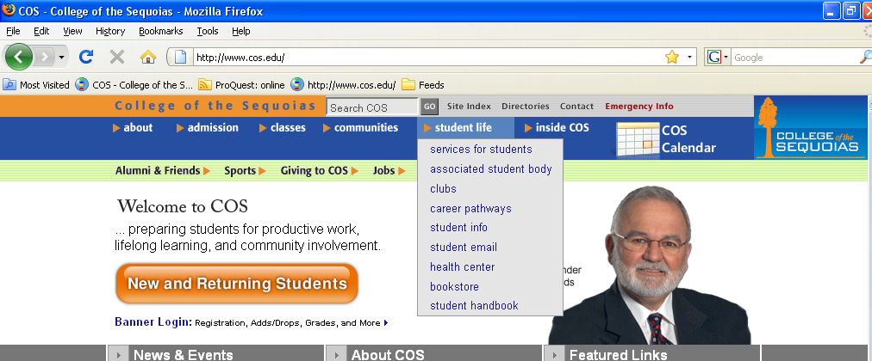

Follow the instructions to activate your COS email account. You may forward your COS email to a personal email account if you wish. Instructions are provided on the link pictured below.
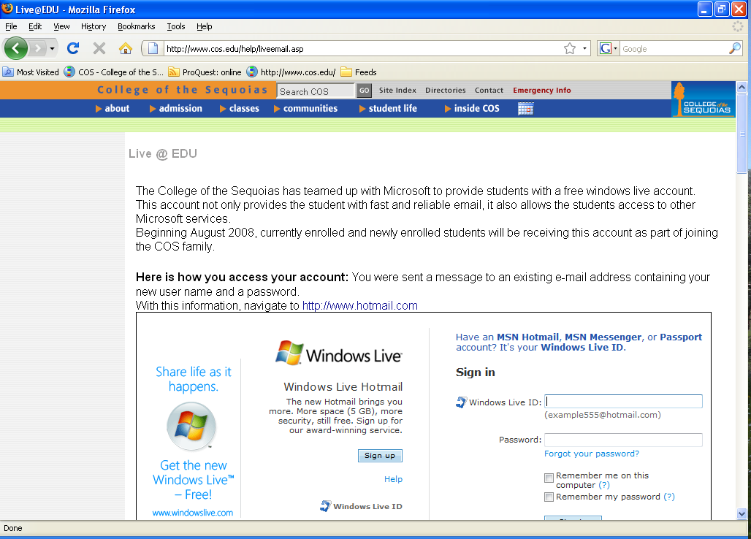

Student Helpdesk
If you need help with Blackboard, please contact the student helpdesk during LRC hours:
Email - Student_Helpdesk@cos.edu
Phone - (559)730-3743

