Distance Education Plan
2017-2020
College of Sequoias

Table of Contents

- DE Task Force Membership
- DECOS Membership
- Introduction
- Executive Summary
- Mission Statements
- Distance Education at COS Defined
- History of DE at COS
- Institutional Planning
- Access/Support for Students
- Professional Development for Faculty/Staff
- Curriculum
- Technology
- Distribution, Monitoring, and Reporting
- Plan Adoption Process
- Appendices

DE Task Force Membership

Tri-Chairs: David Hurst; Deborah Nolan; Mary-Catherine Oxford
Members: Greg Turner; Linda McCauley; Nancy Morgan; Michele Brock; Darcy Kipnis; Joe Sousa; Wendi McLain; Meng Vang

DECOS Membership

Co-Chairs: Deborah Nolan; Mary-Catherine Oxford
Members: Emily Campbell; Glena Crumal ; Tatiana Deeff; Linda DelRio; David Hurst; Susan Mazzola; Lucy DeCaro; Don Rose; Mike Tackett; Jeremy Tierce; Meng Vang. Student Member: Steven Lusk

Introduction

The purpose of the Sequoias Community College District Distance Education (DE) Plan is to provide a roadmap for the growth and sustainability of instructional and student support services for online education. The focus of this plan is the continuous improvement of DE at College of Sequoias (COS) within an environment of collegiality and with respect for Academic Freedom. We are committed to engaging in a dynamic process of planning and assessment that is informed by research and communication in order to develop outstanding DE opportunities for all COS students.

This DE Plan is the result of many factors. With the growth of DE across the nation and in California, there have been changes to accreditation standards related to DE, additional laws enacted, regulations developed specific to DE, and state-wide opportunities such as the Online Education Initiative (OEI) Course Exchange. Additionally, in response to the 2012 Accrediting Commission for Community and Junior Colleges (ACCJC) Show Cause sanction, the District has undergone a major transformation in its governance, planning, decision-making, and resource allocation structures. As part of this major transformation, we recognize the need to develop systematic planning, assessment and evaluation of DE courses and programs. DE requires the support and involvement of Academic Services, Administrative Services and Student Services to meet the needs of our diverse student population efficiently and innovatively (Appendix A).

This DE Plan includes a description of the current state of DE at College of Sequoias (COS) as well as support needs that have been identified in five different areas: Institutional planning; access/support for students; professional development for faculty; curriculum; and technology. Recommendations for action are offered that are designed to ensure high quality DE at COS. It is recommended that the DE plan be distributed across the District to serve as a guide for decision-making and that DECOS monitor and report on the status of the plan annually.

Executive Summary

DE requires the support and involvement of Academic Services, Administrative Services and Student Services to meet the needs of our diverse student population efficiently and innovatively. This plan was created by the DE Task Force and DECOS comprising faculty and staff who believe that to fully integrate DE into institutional planning, access and support for students, professional development for faculty and staff, curriculum development, and technology support, the following actions are recommended:
Institutional Planning. It is recommended that:

- DECOS support annual initiatives to educate and recruit faculty knowledgeable about DE to serve on governance committees.
- The District complete the process to determine if a management position should be created and filled to manage the detailed needs of individual units, support accreditation efforts, and advocate for the digital campus as a whole in the larger governance structure.
- The District complete the process to determine if a full-time computer services Learning Management System (LMS) Administrator position should be created and filled as a classified position.
- The approved DE Plan be shared District-Wide to support decision making.
- DECOS review and report on the DE plan annually.

Access and support for students. It is recommended that the District:

- Provide 24/7 access to a Learning Management System (LMS)
- Maintain the synchronization of Banner and Learning Management System (LMS)
- Assist students who need help with Learning Management System (LMS)
- Ensure accessibility for students with disabilities
- Monitor Last Day of Attendance
- Increase preparedness of students taking DE courses
- Develop and maintain student services DE students can access online

Professional development for faculty/staff. It is recommended that the District:

- Maintain a standard for distance education instruction.
- Provide Faculty and Staff with the resources required to support our distance education students.
- Support the Online Teaching Certificate Program (OTCP)

Curriculum. It is recommended that the faculty:

- Analyze the relevance of DE programs
- Maintain an ongoing, collegial, self-reflective dialogue about the continuous improvement of student learning and institutional processes through Program Review processes and learning outcomes assessment cycles.
- Ensure that DE courses are included in the analysis of student learning in the same way that traditional classes are.
- Compare assessment measures with comparable measures related to traditional face-to-face classes.
- Monitor program development and assess program outcomes regularly.
- Follow approved course outlines and Distance Learning Addendum (DLA) of record.
- Present course objectives, learning outcomes, and requirements in each course.
- Encourage the posting of assignments, due dates, and test dates at the beginning of course or in a way to give reasonable preparation time.
- Describe any face-to-face testing or in person lab situations clearly in the syllabus.
- Encourage the use a variety of teaching strategies, or methodologies, in online classes to support active engagement with content and with each other.
- Review DLA at regular intervals.
- Review instructional materials regularly to maintain currency and effectiveness as part of the course outline update process.
- Encourage DE faculty to contact students at least one week before the beginning of the course to inform them about how to begin.
- Provide information to students about the types and frequency of communication, including feedback to students on assignments, notifying students about how to contact the instructor, notifying students about any unexpected instructor absence or expected delay in communications.
- Maintain mechanisms which support communication within classes, including, but not limited to, announcements, Frequently Asked Questions (FAQ), discussion forums, journals, emails, early warning or alert systems, posted class schedules, due dates, feedback on assignments, course grade or progress, and reminders.

Technology. It is recommended that the District:

            - Provide 24/7 access to a Learning Management System (LMS).
            - Provide 24/7 COS Network access.
            - Provide support to students, faculty and staff in use of LMS through on-campus support personnel.
            - Ensure students are aware of the technology requirements of DE courses.
            - Provide training to support faculty with technology use in the classroom and use of the course management system, or other required technologies.
            - Provide technology failure policies and procedures.

Distribution, monitoring, and annual reporting of the plan will be the responsibility of DECOS.

Mission Statements

COS District Mission Statement

College of the Sequoias is a comprehensive community college district focused on student learning that leads to productive work, lifelong learning and community involvement.
College of the Sequoias affirms that our mission is to help our diverse student population achieve its transfer and/or occupational objectives and to advance the economic growth and global competitiveness of business and industry within our region.
College of the Sequoias is committed to supporting students' mastery of basic skills and to providing access to programs and services that foster student success.

COS Distance Education Mission Statement

The mission of Distance Education at College of the Sequoias (COS) is to extend educational opportunities to a diverse population who prefer or have need of alternative methods of delivery. These approaches to instruction outside the traditional classroom setting provide greater opportunities for students to obtain the education they need to achieve their goals, while continuing with demanding personal and employment schedules.

DE programs support the District Mission Statement through expansion of access to classes. These DE programs provide increased access to higher education to the residents of the District.

DE at COS Defined

While the DE Regulations released in 2008 by the Chancellor’s Office define what the criteria is for distance education, it is up to individual colleges to develop functional descriptions that inform students prior to their enrollment in distance education courses. Therefore, in the schedule of classes, it is important that online and hybrid courses are clearly defined and identified. In an effort to be clear with students, functional descriptions for consistent terminology are identified in the table below:

Descriptor | COS Definition | Processing | Notes
Online | Courses in which students work entirely without having to come to any college facility. Arranged proctored tests are available in this modality (students do not have to come to a COS site to take tests); orientations and/or face-to-face class meetings are optional. Synchronous activities are not required but if scheduled, they may be posted as required archives for asynchronous access. | Requires separate Curriculum Committee approval with Distance Learning Addendum  (DLA) form and follows all quality measures as outlined in the Distance Education Guidelines (i.e. Regular Effective Contact) | Requires faculty readiness standards are met prior to online teaching. If proctoring is required, it cannot be required that students come to campus. Rather, instructors must arrange for a proctoring location in collaboration with the student.
Hybrid | Anytime distance education is offered in lieu of face-to-face class time, where planned face-to-face time is formally scheduled. This designation is also given whenever students are required to come to a COS site for any reason (testing, orientation, etc.) | Requires separate  Curriculum Committee approval with Distance Learning Addendum (DLA) form and follows all quality measures as outlined in the Distance Education Guidelines (i.e. Regular Effective Contact) | If students are required to come to a COS site for any reason, the course is declared a hybrid course to notify students of this requirement.
(Model: Mt. San Jacinto DE Plan, August 2011)

Title 5 Section 55200 Definition and Application. Distance education means instruction in which the instructor and student are separated by distance and interact through the assistance of communication technology. All distance education is subject to the general requirements of this chapter as well as the specific requirements of this article. In addition, instruction provided as distance education is subject to the requirements that may be imposed by the Americans with Disabilities Act (42 U.S.C. §12100 et seq.) and section 508 of the Rehabilitation Act of 1973, as amended, (29 U.S.C. §794d). NOTE: Authority cited Sections 66700 and 70901, Education Code. Reference: Sections 70901 and 70902, Education Code; Title 29 United States Code Section 794d, and Title 42 United States Code Section 12100 et seq. http://extranet.cccco.edu/Portals/1/AA/DE/de_guidelines_081408.pdf

DE Sections

DE programs are intended to supplement, rather than supplant, traditional delivery of our educational programs, and divisions across campus continue to schedule online classes, including Business, Consumer Family Studies, English/Fine Arts, I&T, Math, Counseling, Fire Technology, Library, Nursing, and Social Sciences. Instructors schedule classes in three main formats: (1) entirely online; (2) online with orientation; and (3) hybrid (requiring scheduled meetings in addition to online activity). The table below indicates the number of sections offered in the Spring 2013, 2014, 2015, 2016, Summer 2014, 2015, and 2016, and Fall, 2013, 2014, 2015, and those scheduled for Fall 2016.

Semester | Online Sections
Spring 2013 | 85
Spring 2014 | 96
Spring 2015 | 106
Spring 2016 | 107

Semester | Online Sections
Spring 2013 | 85
Summer 2013 | 0
Summer 2014 | 20
Summer 2015 | 27
Summer 2016 | 35

Semester | Online Sections
Fall 2013 | 91
Fall 2014 | 93
Fall 2015 | 99
Fall 2016 (scheduled) | 106

DE Enrollments

DE enrollments account for about 7% of all District FTES.

Semester | FTES
Spring 2012 | 303.07
Fall 2012 | 329.47
Fall 2013 | 324.33
Spring 2013 | 313.63
Spring 2014 | 324.87
Summer 2014 | 83.5
Fall 2014 | 301.80
Spring 2015 | 116.46
Fall 2015 | 345.61
Spring 2016 | 330.15

Year | DE FTES | COS FTES
2012-2013 | 627.4 | 8,711
2013-2014 | 615.43 | 8,984
2014-2015 | 418.26 | 9,054
2015-2016 | 675.76 | 8,898

2015-2016 Success Data

DE Success rates have been relatively stable since Fall 2014 with an average success rate of 62.9%, which is 6.3% lower than success rates for the same classes delivered on the ground.

 | Fall 2014 | Spring 2015 | Fall 2015 | Spring 2016 | Average
F2F Success | 68.4 | 67.2 | 68.8 | 70.4 | 69.2
DE Success | 62.6 | 58.6 | 62.4 | 63.7 | 62.9
Difference | 5.8 | 8.7 | 6.4 | 6.7 | 6.3

Out-of-state students

The District monitors the numbers of students living outside California who take online classes to comply with federal regulations concerning State Authorization for DE programs. State Authorization is required from each state where COS would be considered to be “doing business.” Our interpretation is that we would not be required to pursue State Authorization from any state at this time.

Fall 2015
- NJ student enrolled in MUS 001
- UT student enrolled in HIST 025
- FL student enrolled in ACCT 210
- NV student enrolled in POLS 010

Spring 2016
- TN student enrolled in BUS 082 and BUS 184
- MO student enrolled in CFS 080, ENGL 002, and PSY 001
- FL student enrolled in BUS 082, CHLD 039, ENGL 002, and ANTH 010 ID student enrolled in POLS 010
- FL student enrolled in BUS 184

The District monitors the numbers of in-state students only taking online classes to support the development and maintenance of comparable online services for all students.

History of DE at COS

The District has responded to a need for a DE delivery option for our diverse student body. The people of Kings and Tulare counties are underserved in terms of easy access to higher education compared to most of California’s population. The District Mission includes the goal “to help our diverse student population achieve their transfer and, or occupational objectives and to advance the economic growth and global competitiveness of business and industry within our region.” As our distance education enrollment growth (from approximately 78 online/hybrid enrollments in Fall 2007 to approximately 3300 enrollments in Spring 2015) suggests, distance education provides critical access to college classes for those living in the COS district which encompasses an immense geographic range with widely scattered communities from the Giant Forest in the Sequoia National Park to Alpaugh and Sultana in the San Joaquin Valley. Many students select online classes due to challenges with reliable regional transportation, family and work obligations that make it difficult to attend classes on campus, or because they prefer the independence and self-reliance required by DE.

College of the Sequoias (COS) has offered DE classes since 1995, initiated by a handful of dedicated faculty. DE class enrollments continued to grow over the decade between 1995 and 2005 and in response to the charge of the framers of the COS Educational Master Plan (2005-2006), the college examined growth in distance education with the intention to “…increase student access as well as the ability of COS to advance the economic growth and global competitiveness of businesses within our District” (p. 50). COS identified its commitment to meeting the educational needs of our students in the Accreditation Self Study (2006) and Accreditation Midterm Report of 2009 by describing courses and programs offered at numerous sites, at different times, and using different distance education methodologies. To advance the implementation of the Master Plan and to support the needs of COS students as identified in the Accreditation Self Study and Five-Year Strategic Plan, the College created and filled a fulltime faculty position, DE Coordinator, in Fall 2007. COS faculty have responded positively to the College’s commitment to distance education by increasing distance education course offerings from 27 online courses in the 2005-2006 academic year to 113 online courses in 2009-2010. Course offerings decreased between 2010 and 2013 due to budget concerns.

Institutional Planning for DE

DE is currently not fully integrated into the decision making and governance structure at COS. Faculty, just as in face to face classes, are responsible for implementing academic standards and encouraging best practices, the governance of which falls under the purview of the Academic Senate. Training and professional development, particularly important for online classes, and pedagogical concerns are similarly Academic Senate issues. On the other hand, the technology, infrastructure, database and LMS maintenance, mechanisms of student verification, and similar issues are District management concerns. Currently, the only committee tasked with integrating these two spheres of influence is DECOS, a subset of Academic Senate which does not participate in Program Review and has no clear path through the governance process to request resources or to influence decisions outside its Academic Senate charter.

Complicating the matter is that academic concerns of individual online classes rightly reside in the discipline that offers them, thus the specific needs of these disciplines should be addressed by their Program Reviews and that area’s dean. However, each of these disciplines operates online essentially in the same technological environment, over which none of the area deans has oversight, nor should it be the responsibility of any one unit in Program Review to request resouces for the whole system.

DE has received increased attention from lawmakers, increased scrutiny from accrediting agencies, and increased opportunities for partnerships and development with, for example, the California Online Education Initiative (OEI). It is important that District online efforts be integral to its mission and that growth should be planned and systematic.

What is needed is to situate DE at COS in our governing mechanisms to consider and prioritize the special needs of the whole online system as well as those needs of individual units and to integrate these needs into a coherent online strategy to implement the District’s overall educational goals and objectives. DE should have a voice in developing Master and Strategic plans and a seat in governance outside just the Academic Senate.

The best way to envision how this integration can come about is to think of DE as a virtual campus. Hardware infrastructure, LMS, and other technologies are the landscape and classrooms of DE.

To fully integrate DE into District institutional planning, the following actions are recommended:

- DECOS support annual initiatives to educate and recruit faculty knowledgeable about DE to serve on governance committees.
- The District complete the process to determine if a management position should be created and filled to manage the detailed needs of individual units, support accreditation efforts (Appendix C), and advocate for the digital campus as a whole in the larger governance structure.
- The District complete the process to determine if a full-time computer services Learning Management System (LMS) Administrator position should be created and filled as a classified position.
- The approved DE Plan be shared District-Wide to support decision making.
- DECOS review and report on the DE plan annually.

Access/Support for Students

In accordance with ACCJC Standards, COS is committed to providing all students with comprehensive Library Services (II.B.1) and Student Support Services (II.C.1.) regardless of location or means of delivery, including DE. These services are described in the general catalog, the schedule of classes, and the District’s website.
COS offers many programs that serve the general student body (Academic Counseling, Learning Resource Center, Financial Aid, Student Health Center, etc.), as well as specialized services designed for certain student populations (Access and Ability Center, Extended Opportunity Programs and Services/Cooperative Agencies Resource for Education, Cal WORKS). It is recommended that a review of resources available to student taking DE courses be conducted with input from various student services offices to determine if a streamlined process can be identified that offers students the ability to complete the steps of matriculation in a format that supports distance education learners.

The general college orientation process includes information for students about DE classes. However, DECOS has discovered that approximately 30% of students enrolled in online classes have enrolled because they thought online classes would be easier than face-to-face classes (Online Readiness Survey Data, Appendix G). DECOS has made an effort to support student awareness of the differences between online and face-to-face classes by sending pre-course messages to students and giving them tips on being successful in an online learning environment. Additionally, a confirmation mechanism in Banner exists that alerts students to the fact that they are registering for an online class and that online learning has some important differences about which students should be aware.

Success rates may be improved with better up-front preparation of students, along with development of course structures that communicate clear expectations for student learning and regular and effective contact initiated by instructors. With the assistance of DECOS members, a survey was developed in the spring 2013 semester designed to ascertain what behaviors, conditions, and dispositions students and faculty felt were important to being a successful online student.

The following recommendations for student access and support also support COS Institutional Goals and Institutional Objectives (Appendix F):

Recommendations for Student Access (District Objectives 1.1, 2.1, 2.2)
    - Provide 24/7 access to a Learning Management System (LMS)
    - Maintain the synchronization of Banner and Learning Management System (LMS)
    - Assist students who need help with Learning Management System (LMS)
    - Ensure accessibility for students with disabilities
    - Monitor Last Day of Attendance

Recommendations for DE Student Support (District Objectives 2.1, 2.2, 3.1, 3.2)
            - Increase preparedness of students taking DE courses
- Maintain a webpage for online students with resources and tutorials regarding DE.
- Ensure systems are in place that make students aware they are registering for a DE course.
- Share information regarding the time management skills, reading comprehension skills, and computer skills required to be successful in DE courses.
- Provide counselors with the tools necessary to guide students interested in taking DE courses.
- Prepare students for online classes, including, but not limited to an orientation and readiness survey.
2. Develop and maintain specific instructional support and counseling services DE students can access online (District Objectives 2.2, 2.3, 3.1, 3.2, 4.1)
a. Provide access to online tutoring for multiple disciplines.
b. Evaluate and market online tutoring.
c. Create Library/Learning Resource module for LMS.
d. Ensure online access to Library collection and reference assistance.
e. Maintain a mechanism for allocation of resources to plans for DE
f. Create full service online counseling, including the following:
1. Online live chat with a counselor so that the Student Educational Plan (SEP) can both be developed and signed via an online counseling session.
2. Make online forms available and a process for submitting the forms for students to take care of requests such as prerequisite overrides, graduation applications, demographics changes, etc.
3. Online degree/certificate audit.
4. Many of the processes in our Admissions and Records office along with our Financial Aid office also need to be replicated in the online arena.

Professional Development for Faculty/Staff

DE instruction requires compliance with legal and ethical obligations. Faculty and staff need training and resources to support their efforts on an ongoing basis. (Appendices B, D, E, and H). Recommendations regarding DE professional development for faculty and staff include the following:

- Maintain a standard for distance education instruction.
  - Maintain an online teaching certification equivalency process that involved input from DECOS.
  - Support the Online Teaching Certification Program (OTCP).
  - Ensure faculty are aware of communication standards for online teaching that support the COS Regular and Effective Contact policy and good teaching practices.
  - Provide faculty with formative and summative course evaluation tools.

- Provide Faculty and Staff with the resources required to support our distance education students.
  - Ensure that the faculty are aware of student readiness levels and resources (Appendix I)
  - Ensure faculty and staff are aware of the support services available to DE students to support their success (Appendix J).
  - Encourage faculty to provide multiple methods of content delivery and student engagement
  - Provide faculty with course review support that results in quality online course offerings
  - Provide opportunities for faculty to learn about theories in order to make effective decisions about the use of online teaching methodologies that require active participation on the part of students and faculty.
  - Provide training opportunities and information to encourage faculty to incorporate a variety of student learning assessment methods.
- Ensure that the COS policy on Academic Freedom applies to DE
- Measure faculty satisfaction with online teaching

Curriculum

Title 5 (§55202) requires that the same standards of course quality shall be applied to distance education as are applied to traditional classroom courses. DECOS recommends that DE classes reflect DE-specific standards developed by the Online Education Initiative (OEI) in 2013 (Appendix H). The following recommendations are outlined in an effort to make progress on the COS Institutional Goals and Institutional Objectives (Appendix F).

All DE courses receive separate Distance Education Coordinator and Curriculum Committee approval for distance education delivery. The Coordinator and the Curriculum Committee must approve a Distance Learning Addendum (Appendix G) that addresses regular and effective contact, how a class promotes the college mission, and adaptations of delivery for the online environment. Once passed by the coordinator and Curriculum Committee, all curriculum proposals require subsequent Board of Trustees approval.

Divisions continue to be responsible for the development of programs and curriculum that meet the distance education needs of students. The decision to offer courses at a distance are made at the division level including the identification of appropriate modalities of delivery and suitability for distance education courses for each individual certificate and degree. The Distance Education Coordinator is available for consultation to assist in these types of decisions. In the program review process, all divisions are required to examine success and retention data for distance education sections and compare to non-distance sections of the same course. Additionally, all divisions engage in the process of developing and assessing course outcomes to inform instructional decisions.

Recommendations regarding Distance Education Curriculum (District Objectives 2.1, 2.2, 2.3, 3.1, 3.2, 4.1, 4.2)
- Analyze the relevance of DE programs.
- Maintain an ongoing, collegial, self-reflective dialogue about the continuous improvement of student learning and institutional processes through Program Review processes and learning outcomes assessment cycles.
- Ensure that DE courses are included in the analysis of student learning in the same way that traditional classes are.
- Compare assessment measures with comparable measures related to traditional face-to-face classes.
- Monitor program development and assess program outcomes regularly.
- Follow approved course outlines and Distance Learning Addendum (Appendix G) of record.
- Present course objectives, learning outcomes, and requirements in each course.
- Encourage the posting of assignments, due dates, and test dates at the beginning of course or in a way to give reasonable preparation time.
- Describe any face-to-face testing or in person lab situations clearly in the syllabus.
- Encourage the use a variety of teaching strategies, or methodologies, in online classes to support active engagement with content and with each other.
- Review DLA at regular intervals.
- Review instructional materials regularly to maintain currency and effectiveness as part of the course outline update process.
- Encourage DE faculty to contact students at least one week before the beginning of the course to inform them about how to begin.
- Encourage faculty to provide information to students about the types and frequency of communication, including feedback to students on assignments, notifying students about how to contact the instructor, notifying students about any unexpected instructor absence or expected delay in communications.
- Maintain mechanisms which support communication within classes, including, but not limited to, announcements, Frequently Asked Questions (FAQ), discussion forums, journals, emails, early warning or alert systems, posted class schedules, due dates, feedback on assignments, course grade or progress, and reminders.

Technology

DE relies on a District-supported technological environment. In order for DE to function successfully, the following actions are recommended (District Objectives 3.1, 3.2, 4.1):
- Provide 24/7 access to a Learning Management System (LMS).
- Provide 24/7 COS Network access.
- Provide support to students, faculty and staff in use of LMS through on-campus support personnel.
- Ensure students are aware of the technology requirements of DE courses.
- Provide training to support faculty with technology use in the classroom and use of the course management system, or other required technologies.
- Provide technology failure policies and procedures.

DE Plan Distribution, Monitoring, and Reporting Process

Upon approval, it is recommended that the DE Plan be distributed to all faculty and staff throughout the District. It is also recommended that DECOS monitor the distribution and activity related to the DE plan and report to the Academic Senate on the plan implementation and feedback on an annual basis.

DE Plan Adoption Process

The DE Task force convened to write an initial draft of the DE plan in 2015-2016. In 2016-2017, DECOS reviewed and approved the recommendation to Senate. The Academic Senate approved the plan in March of 2017. The District Governance Senate considered the plan in April 2017.

Appendices

- Responsible Parties
- ACCJC Policy on DE and CE (2012)
- ACCJC 5.3 Evidence and DE Plan Outcomes Matrix
- COS AP 4105
- COS Regular and Effective Contact Policy
- Summary: Institutional Goals 2015-2025 and Institutional Objectives 2015-2018
- COS Distance Learning Addendum
- OEI Standards
- Online Readiness Survey
- Online Success Survey

Appendix A: Responsible Parties
DE Plan Tasks | Academic Services | Student Services | Administrative Services
24/7 access to LMS |  |  | Computer Services, Canvas Admin
Accessibility for students with disabilities |  | AAC
Allocation of resources for DE |  | DE Director | Finance
Analyze relevance of DE programs | Divisions
Canvas Account Development | DE Coordinator |  | Canvas Admin
Canvas Administration Notices (including feature updates) | DE Coordinator |  | Canvas Admin
Canvas Analytics and Reports | DE Coordinator |  | Canvas Admin
Canvas Course Content Management | DE Coordinator |  | Canvas Admin
Canvas Course Design support | DE Coordinator |  | Canvas Admin
Canvas course merges |  |  | Canvas Admin
Canvas manual enrollments (audits, support personnel) | DE Coordinator |  | Canvas Admin
Canvas Manually Created Courses | DE Coordinator |  | Canvas Admin
Canvas Service Liaison | DE Coordinator |  | Canvas Admin
Communication regarding student support services for online students | DECOS, DE Coordinator | DE Director
Communication to faculty regarding DE standards | DE Coordinator
Communication to online students | DE Coordinator | DE Director | Computer Services, Canvas Admin
Counselor advice | DE Coordinator | Counseling
Include relevant information about DE in catalog, including definitions | Divisions, DE Coordinator | DE Director
Include relevant information about De in schedule of classes | Divisions
LMS training | DE Coordinator |  | Canvas Admin
Maintain dialogue about outcomes assessment | Divisions
Maintain integrity and effectiveness of Canvas |  |  | Canvas Admin
Maintain online teaching certification program | DE Coordinator
Maintaining email system |  |  | Computer Services
Measure faculty satisfaction with online teaching | DECOS
Monitoring LDA |  | DE Director
Online counseling |  | Counseling
Online LRC |  | LRC
Online pedagogy resources and training | DE Coordinator
Online tutoring |  | LRC
Present course outcomes in syllabi | Divisions
Provide 24/7 access to COS network |  |  | Computer Services
Provide Canvas instruction for students |  | LRC
Provide technology failure policies and procedures |  |  | Computer Services
Review Distance Learning Addendum | DECOS, Curriculum Committee
Review online instructional materials | Curriculum Committee
Review Student Services resources for DE students | DECOS | DE Director
SIS Integration |  |  | Computer Services, Canvas Admin
Student Helpdesk |  | DE Director
Student success orientation, readiness, and skills (e.g., time management) |  | DE Director
Support online course quality evaluation | DECOS, DE Coordinator
Third Party App integration and implementation |  |  | Canvas Admin
Website resources and tutorials | DE Coordinator |  | Computer Services

Appendix B: ACCJC Policy on DE and CE

ACCREDITING COMMISSION FOR COMMUNITY AND JUNIOR COLLEGES
Western Association of Schools and Colleges

Policy on Distance Education and on Correspondence Education

(Adopted June 2001; Edited August 2004; Revised June 2005, January 2010, June 2011;
Edited August 2012)

Background

Recognizing that most accredited institutions are making use of the growing range of modalities for delivery of instructional and educational programs and services, including various electronic means, the Commission has adopted a policy based on principles of good practice to help ensure that distance learning is characterized by the same expectations for quality, integrity, and effectiveness that apply to more traditional modes of instruction.

This policy reflects the federal regulatory requirements regarding distance education and correspondence education.

Definition of Distance Education (34 C.F.R. § 602.3.)
Distance Education means:

Education that uses one or more of the technologies listed in paragraphs (1) through (4) to deliver instruction to students who are separated from the instructor and to support regular and substantive interaction between the students and the instructor, either synchronously or asynchronously. The technologies may include:

- the internet;
- one-way and two-way transmissions through open broadcast, closed circuit, cable, microwave, broadband lines, fiber optics, satellite, or wireless communications devices;
- audioconferencing; or
- video cassettes, DVDs, and CD-ROMs, if the cassettes, DVDs, or CD-ROMs are used in a course in conjunction with any of the technologies listed in paragraphs (1) through (3).

Definition of Correspondence Education (34 C. F. R. § 602. 3.)
Correspondence education means:

- education provided through one or more courses by an institution under which the institution provides instructional materials, by mail or electronic transmission, including examinations on the materials, to students who are separated from the instructor.
- interaction between the instructor and the student is limited, is not regular and substantive, and is primarily initiated by the student.
- correspondence courses are typically self-paced.
- correspondence education is not distance education.

Policy on Distance Education and on Correspondence Education
44

Policy

Commission policy specifies that all learning opportunities provided by accredited institutions must have equivalent quality, accountability, and focus on student outcomes, regardless of mode of delivery. This policy provides a framework that allows institutions the flexibility to adapt their delivery modes to the emerging needs of students and society while maintaining quality. Any institution offering courses and programs through distance education or correspondence education is expected to meet the requirements of accreditation in each of its courses and programs and at each of its sites.

Policy Elements

- development, implementation, and evaluation of all courses and programs, including those offered via distance education or correspondence education, must take place within the institution's total educational mission.
- institutions are expected to control development, implementation, and evaluation of all courses and programs offered in their names, including those offered via distance education or correspondence education.
- institutions are expected to have clearly defined and appropriate student learning outcomes for all courses and programs, including those delivered through distance education or correspondence education.
- institutions are expected to provide the resources and structure needed to accomplish these outcomes and to demonstrate that their students achieve these outcomes through application of appropriate assessment.
- institutions are expected to provide the Commission advance notice of intent to initiate a new delivery mode, such as distance education or correspondence education, through the substantive change process.
- institutions are expected to provide the Commission advance notice of intent to offer a program, degree or certificate in which 50% or more of the courses are via distance education or correspondence education, through the substantive change process. For purposes of this requirement, the institution is responsible for calculating the percentage of courses that may be offered through distance or correspondence education.
- institutions which offer distance education or correspondence education must have processes in place through which the institution establishes that the student who registers in a distance education or correspondence course or program is the same person who participates every time in and completes the course or program and receives the academic credit2. This requirement will be met if the institution verifies the identity of a student who participates in class or coursework by using, at the institution's discretion, such methods as a secure log­ in and password, proctored examinations, other technologies and/or practices that are developed and effective in verifying each student's identification. The institution must also publish policies that ensure the protection of student privacy and will notify students at the time of class registration of any charges associated with verification of student identity 34
C.F.R. § 602.17(g).

2 See Addendum: WCET Best Practice Strategies to Promote Academic Integrity in Online Education Version 2.0, June
2009.

Policy on Distance Education and on Correspondence Education
45

Appendix C: ACCJC Evidence

ACCJC 5.3 Evidence & DE Plan Outcomes Matrix

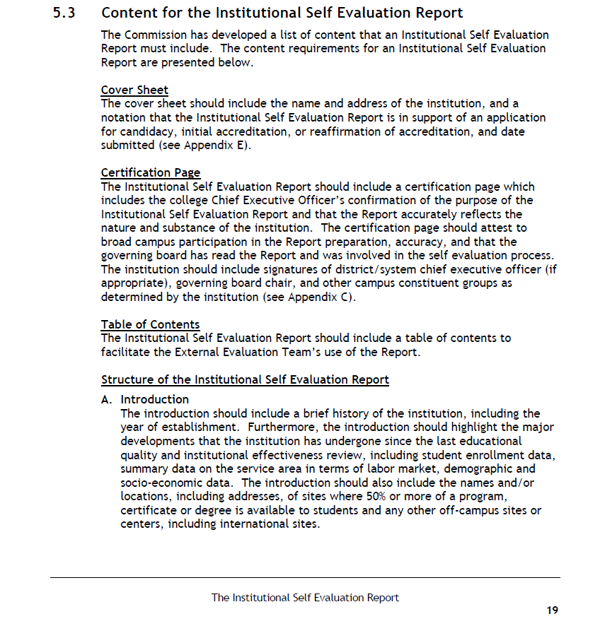

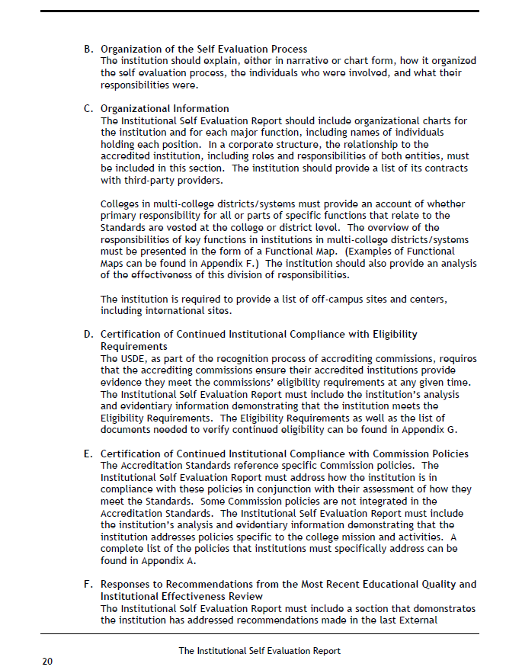
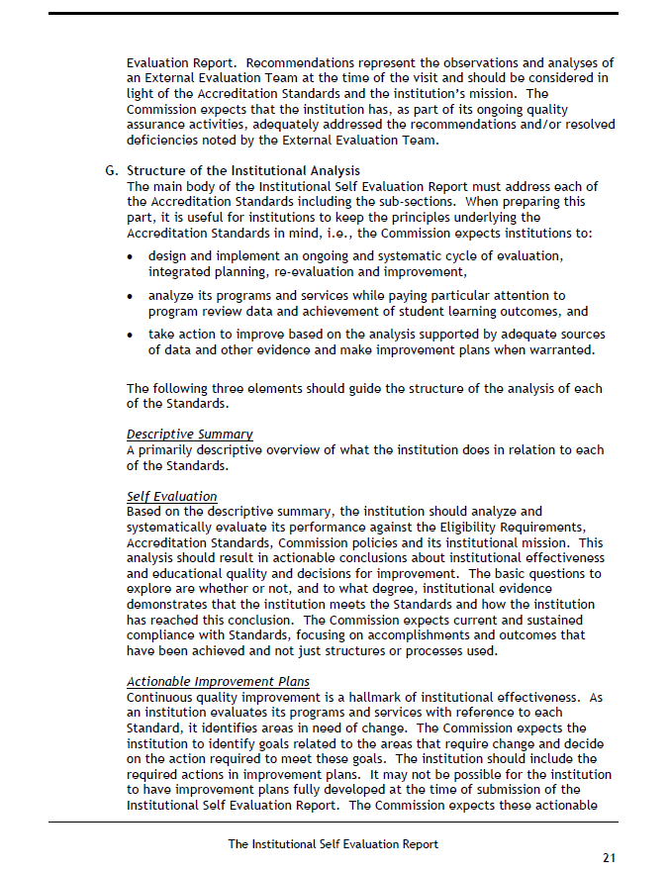
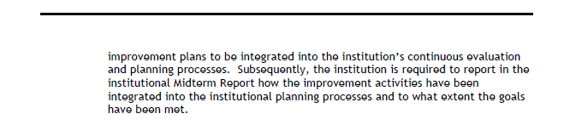

Appendix D: AP 4105
ADMINISTRATIVE PROCEDURE 4105
SEQUOIAS CCD Academic Services

DISTANCE EDUCATION AND STUDENT AUTHENTICATION PROCESS
- Definition: Distance education allows the exploration and development of educational initiatives using advanced communication and computing technologies to address student access issues related to geographical, cultural, disability or facility barriers. A distance education course/section or session is defined as the use of technology utilized 51 percent or more of the time to deliver instruction during the course term and where the student and instructor are separated by distance. (CCC Distance Education Guidelines)

Distance education instruction is subject to requirements of the Americans with Disabilities Act and the Rehabilitation Act of 1973 (Section 55200). The Director of the Access and Ability Center will assure that all accommodations are accessible to students with disabilities as outlined in the California Community Colleges Distance Education Guidelines, 2012 edition.

- Course Approval: Each proposed or existing distance education course shall be reviewed and approved separately. Separate approval is mandatory if any portion of the instruction in a course or a course section is designed to be provided through distance education.

The review and approval of new and existing distance education courses shall follow the curriculum approval procedures outlined in Administrative Procedures 4020 or 4022.

- Course Quality Standards: The same standards of course quality shall be applied to distance education as are applied to traditional classroom courses (Title 5, Section 55202).

- Course Quality Determinations: Determinations and judgments about the quality of the distance education course were made with the full involvement of the Curriculum Committee, the Academic Senate, and the Board of Trustees according to Sequoias CCD approval procedures.

- Duration of Approval: All distance education courses approved under this procedure will continue to be in effect unless changes are warranted through the regular review cycle or there are substantive changes of the course outline.

- Instructor Contact: All approved distance education courses include regular effective contact between instructor and students, through group or individual meetings, orientation and review sessions, supplemental seminar or study sessions field trips, library workshops, telephone contact, correspondence, voice mail, e-mail, or other activities (Title 5, Section 55204). Online courses that do not involve regular and effective contact between instructors and students may

be considered correspondence courses for which apportionment cannot be claimed.

A regular, effective contact audit form, developed by the DECOS committee, is available to instructors who wish to use it as a tool to develop, assess, and maintain course structures and online instructional practices that promote and document regular, effective contact in online courses. The use of the audit form is optional and is not intended as a faculty evaluation tool. The audit form can be found on the DECOS website.

For the Sequoias CCD, authentication uses secure credentialing/login and password within the COS email system and applicable course management systems, as specifically referenced in the federal regulation as appropriate and accepted procedures for verifying a student’s identity. The email and Blackboard methods involve secure credentialing/login and password using Banner ID and randomly generated password retrieved from Banner. The other method involves photo ID authentication at hybrid sessions in order to receive password to other course management systems.

The regular, effective contact policy located on the DECOS website assures high quality online education. Any changes to this policy will be made in collegial consultation between the Academic Senate and COSTA.

It is important to document regular effective contact and how it is achieved. Documentation may include email archives, discussion board archives, anecdotal records, and inclusion of information in applicable syllabus and/or curriculum outlines of record on the type and frequency of interaction appropriate to each online course/section or session. Standards for documentation may be established by individual divisions, departments, and individual instructors.

- Faculty Selection and Workload: Instructors of course sections delivered via distance education technology shall be selected by the same procedures used to determine all instructional assignments. Instructors shall possess the minimum qualifications for the discipline into which the course’s subject matter most appropriately falls. The number of students assigned to any one course section offered by distance education will be determined by and be consistent with other District procedures related to faculty assignment. (Title 5, Section 55208)

- Student Authentication Process: Consistent with federal regulations pertaining to federal financial aid eligibility, the District must authenticate or verify that the student who registers in a distance education or correspondence education course is the same student who participates in and completes the course or program and receives the academic credit. The District will provide to each student, at the time of registration, a statement of the process in place to protect student privacy and estimated additional student charges associated with verification of student identity, if any.

The Vice President of Academic Services shall authorize one or more of the methods to authenticate or verify the student’s identity approved by federal regulation.

For the Sequoias CCD, authentication uses secure credentialing/login and password within District email systems and applicable course management systems, which is specifically referenced in the federal regulation as an appropriate and accepted procedure for verifying a student’s identity. The email and course management systems method involves securing credentialing/login and password using Banner ID and randomly generated password retrieved from Banner. The other method involves photo ID authentication at hybrid sessions in order to receive password to other course management system.

The Vice President, Academic Services shall establish procedures for providing a statement of the process in place to protect student privacy and estimated additional student charges associated with verification of student identity, if any, to each student at the time of registration.

- Student’s Last Day of Attendance: A student’s last day of attendance in an online class is determined by one or more of the following activities:
- Opening, editing, or submitting an assignment online using the Course Management System assignment feature, by email, or in person.
- Participating in an online discussion.
- Engaging in an exam either online or in person.
- Engaging in course activity beyond login (e.g., wiki, blog, group) as demonstrated by record in Blackboard Course report.

A faculty member is encouraged to store the following evidence in such a manner that it can be easily retrieved should the College be audited:
- Record of student’s grade for assignment or test and corresponding due date.
- Course report (Course Management System) of user activity beyond login.
- Email.

- Ongoing Responsibility of Districts: Title 5, Section 55210 requires that the District maintain records and report data through the Management Information System on the number of students and faculty participating in new courses or sections of established courses offered through distance education. In addition, the District shall provide other information as deemed necessary by the Board of Governors.

- Reporting: The Distance Education Coordinator will make an annual report to the Board of Trustees addressing the current state of distance education at COS.

References: Title 5, Section 55200 et seq.; California Community Colleges Distance Education Guidelines, March 2004.
Form: Curriculum Committee Distance Education Form Adopted: May 12, 2009
Revised: April 8, 2013
Revised: May 13, 2015

Appendix E: Regular and Effective Contact Policy

COS Regular, Effective Contact Policy for Online Classes

Background
District governing boards shall ensure that: Any portion of a course conducted through distance education includes regular effective contact between instructor and students, through group or individual meetings, orientation and review sessions, supplemental seminar or study sessions, field trips, library workshops, telephone contact, correspondence, voice mail, e-mail, or other activities. (Title 5 §55204 Instructor Contact)

Purpose
The purpose of the regular, effective contact policy is to provide faculty with the recommendations of the Distance Education at COS Committee (DECOS) for assuring high quality online education Any changes to this policy will be made in collegial consultation between the Academic Senate and COSTA.

Effective contact features include those that:
- are instructor-initiated
- are outlined in the syllabus
- enable student-instructor contact
- are timely (as outlined in the syllabus)
- use available acceptable contact methods
- are documented

Recommended minimum contact standards for online courses:
- It is the responsibility of the instructor in an online course to initiate regular contact with enrolled students. Initiate means that the instructor facilitates the beginning of instructor-student interaction. For example, the instructor posts an announcement on the course management system. The instructor’s and/or department’s policy describing the frequency and timeliness of instructor-initiated contact, instructor feedback, and student responsibility, will be posted in the syllabus and/or other course documents that are made available for students when the course officially opens each semester. If the instructor must be out of contact briefly for an unexpected reason, notification to students, including when students can expect regular effective contact to resume, should be made through typical course communication channels.

- The use of the term “regular effective contact” in this context suggests that students should have frequent opportunities to ask questions and receive answers from the instructor of record. It is recommended that instructors have a threaded discussion that is set aside for general questions about the course and weekly or other question and answer sessions available to students.

- For online courses, there are a number of acceptable interactions between instructor and student, not all of which may require in-person contact. Acceptable interactions include:
email correspondence; threaded discussion forums with appropriate instructor participation; weekly announcements in the course management system; timely feedback for student work; face-to-face classroom encounters, orientations, and review sessions; field trips; correspondence via the U. S. Postal Service; online interactions via chats, discussions, or other appropriate online technology; phone;and videoconferences. It is important to document regular effective contact and how it is achieved. Documentation may include email archives, discussion board archives, anecdotal records, and inclusion of information in applicable syllabus and/or curriculum outlines of record on the type and frequency of interaction appropriate to each online course/section or session. Standards for documentation may be established by individual divisions, departments, and individual instructors.

Approved by Academic Senate, May 2009

Appendix F: Institutional Goals and Objectives
Summary: Institutional Goals 2015-2025 and Institutional Objectives 2015- 2018

District Goal #1. College of the Sequoias will increase student enrollment relative to population growth and educational and workforce development needs.

District Objective 1.1: Increase overall enrollment by 1.75% annually.

District Goal #2. College of the Sequoias will improve the rate at which its students complete degrees, certificates, and transfer objectives.
District Objective 2.1: Increase the number of students who are transfer-prepared annually. District Objective 2.2: Increase the number of students who earn an associate degree or certificate
annually.

District Objective 2.3: Increase course success and completion rates in pre-transfer English, Math, and English as a Second Language courses annually.

District Objective 2.4: Increase Career Technical Education course success rates and program completion annually.

District Goal #3. College of the Sequoias will strategically tailor and implement academic programs and student services that match the unique needs of its student population and the demands of ongoing changes in workforce development.

District Objective 3.1: Reduce the achievement gap of disproportionately impacted student groups annually, as identified in the Student Equity Plan.

District Objective 3.2: Increase training for academic and student services staff and faculty to respond to the unique needs of our student population.

District Goal #4. College of the Sequoias Board of Trustees, administration, faculty, and staff will engage in best practices and staff development to sustain effective operational systems for institutional assessment and continuous improvement.

District Objective 4.1: Improve operational systems based upon data driven decision-making as described in the COS 2.0 manuals.

District Objective 4.2: Improve the efficiency, effectiveness and communication of human, physical, technological, and financial resources to advance the District Mission.

Appendix G: Distance Learning Addendum

College of Sequoias

Distance Learning Addendum – Annotated Version

Planning Process

(ACCJC: Description of the analysis undertaken to determine need for the new instructional delivery mode. Evidence that delivery systems and modes of instruction are designed to, and do in fact, meet student needs and align with the college mission. Description of how delivery mode is considered in curriculum development process; how student learning outcomes (SLOs) data is collected, assessed, and used for improvement. What established policies and institutional processes guide the development and evaluation of courses and programs offered in DE mode? Are they different from the policies and institutional processes that guide the development and evaluation of courses offered in traditional mode? What is the rationale?)

What is the purpose for offering the course online and how does online delivery of the course support division

How does the course help the college fulfill the college mission?

Effectiveness
(ACCJC: Description of how effectiveness, including SLOs and assessment of the delivery mode, will be evaluated; how the delivery mode will be reviewed compared with other modes of instruction. Evidence of student success, retention, and achievement data; comparability with face-to-face delivery student success, retention, and student achievement data. Evidence that data has been analyzed for DE/CE and face-to-face students in order to compare student achievement and attainment of expected learning outcomes.)
Will student learning assessment in this course differ from face-to-face delivery of the same course? If so, explain how.
Yes Explanation: _________________________________________________________
No
Will you use a formative mid-course evaluation (such as a survey) process? If so, how will results be used to improve student success?
Yes Explanation: _________________________________________________________
No

Scheduling
Sections of this course may be scheduled as (select all that apply)
Online with orientation
Online/hybrid
Online

Date of Last Attendance
(ACCJC: Evidence that DE/CE student attendance in courses/programs is monitored.)
(Federal Financial Aid: The WICHE Cooperative for Educational Technology (WCET) writes “last day of attendance” is to determine the amount of aid a student is eligible to receive when that student withdraws or leaves a program without officially notifying the institution.)
(AP 4015: E, A student’s last day of attendance in an online class is determined by one or more of the following activities: opening, editing, or submitting an assignment online using the course management system assignment feature, by email, or in person; participating in an online discussion; engaging in an exam either online or in person; engaging in course activity beyond login (e.g., wiki, blog, group) as demonstrated by record in course management report.)
In addition to course management system access records, monitoring and documenting student attendance in the class will include (select all that apply):
Opening, editing, or submitting an assignment online using the Course Management System assignment feature, by email, or in person.
Participating in an online discussion.
Engaging in an exam either online or in person
Engaging in course activity beyond login (e.g., wiki, blog, group) as demonstrated by record in Blackboard Course report.

While participation is strictly voluntary, the faculty member is encouraged to store the following evidence in such a manner that it can be easily retrieved should the College be audited:
Record of student’s grade for assignment or test and corresponding due date.
Email messages

Course Management System
(ACCJC: Description of faculty resources and technical support for the mode of delivery)

What course management system will you use?

Canvas
MyMathLab
Pearson
Other: Please explain ___________________________________________________________
What resources are available for student and instructor technical support?
COS Helpdesk
Other: Please explain ___________________________________________________________
How will you notify students about what to do if access to the course management system is interrupted?
Syllabus
Orientation
Other: Please explain ___________________________________________________________

Student Authentication
(ACCJC: Institutions which offer distance education or correspondence education must have processes in place through which the institution establishes that the student who registers in a distance education…course or program is the same person who participates every time in and completes the course or program and receives the academic credit. What mechanisms does the institution have for informing students and faculty about, and enforcing, its policies on academic honesty, including DE courses and programs? Does the policy appropriately ensue the protection of student privacy in the verification process?

(AP 4015: D. Student Authentication Processes: Consistent with federal regulations pertaining to federal financial aid eligibility (Higher Education Act), the District must authenticate or verify that the student who registers in a distance education . . . course or program is the same student who participates in and completes the course or program and receives the academic credit. The District will provide to each student, at the time of registration, a statement of the process in place to protect student privacy and estimated additional student charges associated with verification of student identity, if any.

Which of the accepted methods of student authentication will you use to ensure that the student participating in your class is the student who is registered for the class (per AP 4105)? (select all that apply)
Blackboard log in
Email
Proctored exam with photo ID

Academic Integrity Policy
(ACCJC - Evidence of how policies on academic honesty are disseminated to students enrolled in DE programs. How are policies and information about academic honesty and student verification made available to students? Does the institution have a college-wide policy on academic honesty? Does the policy address issues on academic honesty, including verification of student identity, in relation to registration for, participation in, and completion of DE? Does the institution have a policy on academic freedom? How is this policy implemented and monitored in DE courses and programs?)

How will you notify students of the academic integrity policy for your class? (select all that apply)
Syllabus
Orientation
Email as needed
Other: Please explain ___________________________________________________________

Online Adaptation of Instructional Strategies
(ACCJC - Evidence that DE courses are of sufficient content, breadth, and length to permit the student to learn and practice expected knowledge, skills, and abilities. By what means does the institution ensure that the students develop the listed skills in DE mode? How does the institution know that these means are effective? What criteria does the college use to assure that the required skill level of students in DE courses and program meet collegiate standards and rigor? How effectively does DE facilitate student learning? Is the level of effectiveness for facilitating student learning different from traditional delivery modes?)

Indicate which instructional strategies will be adapted from traditional delivery to online delivery.
Lecture
Group activity
Reading material
Media
Other: Please explain _____________________________________________

Accessibility for Students with Disabilities (ADA, Section 508)
Is there any aspect of the course that cannot be made accessible to students with disabilities? If so, explain how the course will address accessibility.
Yes Explanation: _________________________________________________________
No

Online Adaptation of Assessment
(ACCJC - Evidence that DE courses are of sufficient content, breadth, and length to permit the student to learn and practice expected knowledge, skills, and abilities. By what means does the institution ensure that the students develop the listed skills in DE mode? How does the institution know that these means are effective? What criteria does the college use to assure that the required skill level of students in DE courses and program meet collegiate standards and rigor? How effectively does DE facilitate student learning? Is the level of effectiveness for facilitating student learning different from traditional delivery modes? Evidence that proctored exam sites are approved. Institutions are expected to provide the resources and structure needed to accomplish these outcomes and to demonstrate that their students achieve these outcomes through application of appropriate assessment.)

Indicate which formative and summative assessment methods will be adapted from face-to-face to the online classroom.
Quiz
Test
Performance
Other: _________________________________________________
Oral Communication
Telephone
Web conference
Video
Audio recording
Other: Please explain _________________________________________________
If you will be using an external location for a proctored exam, explain the process for approving the proctoring site.

Regular and Effective Contact
(ACCJC: Evidence of a policy that defines “regular and substantive interaction" (34 C.F.R. § 602.3.)

(AP 4105: B.4, All approved distance education courses include regular effective contact between instructor and students . . . . Title 5, Section 55204. Online courses that do not involve regular and effective contact between instructors and students may be considered correspondence courses for which apportionment cannot be claimed.)

Indicate which options below you will use to initiate regular and effective instructor-student contact (select all that apply):
Asynchronous
Discussion board
Email
Announcements
Other: Please explain ____________________________________________________
Synchronous
Face-to-face meetings
Chat
Telephone
Web conference
Other: Please explain____________________________________________________

How will you inform your students of the frequency of your contact? (select all that apply)
Syllabus
Orientation
Email as needed
Other: ____________________________________________________________
How will you inform your students in the event of your absence? (select all that apply)
Syllabus
Orientation
Email as needed
Other: Please explain____________________________________________________________

Student Readiness and Support
(ACCJC: Evidence that the college prepares and monitors DE/CE students to be successful. Evidence that student readiness has been addressed.)

How will you help students gauge their readiness for being successful in an online class?
Survey
Interview
Performance
Other: Please explain____________________________________________________________
How will you inform students of your expectations for student participation and technology requirements?
Syllabus
Orientation
Email as needed
Other: Please explain____________________________________________________________
How will you inform students of college support services?
Syllabus
Orientation
Email as needed
Other: Please explain ____________________________________________________________

Appendix H: OEI Course Design Rubric

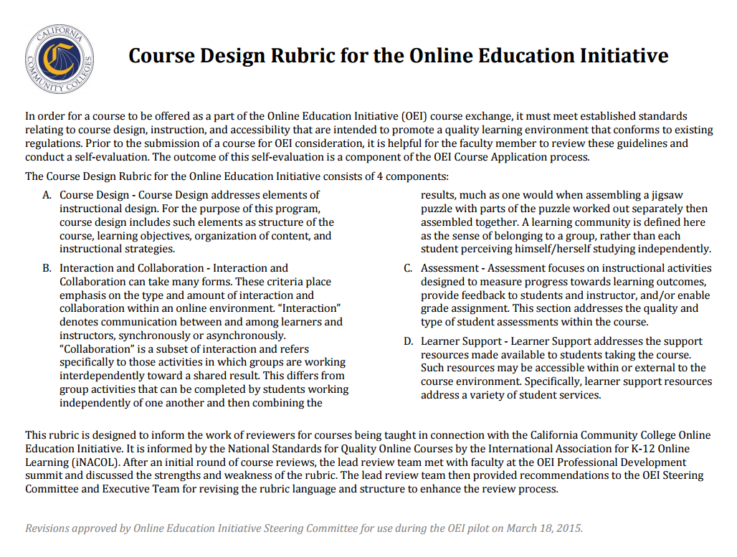
Appendix I: Online Learning Readiness Survey
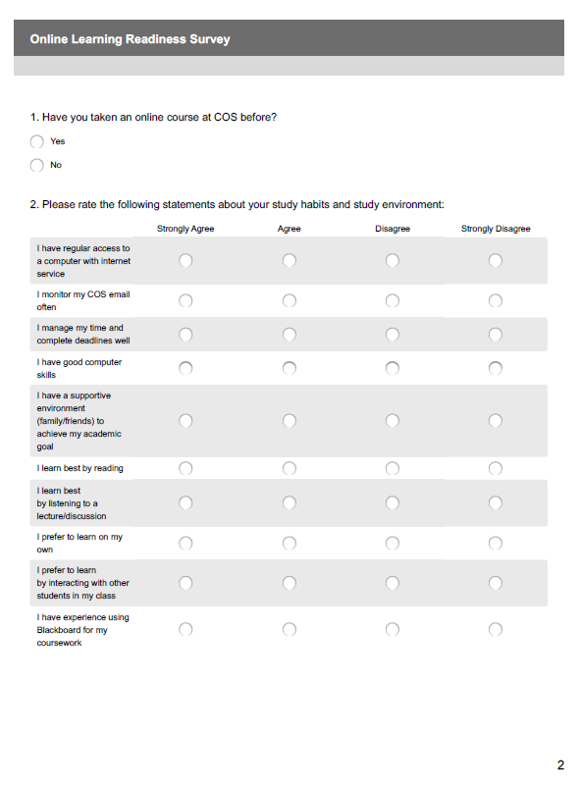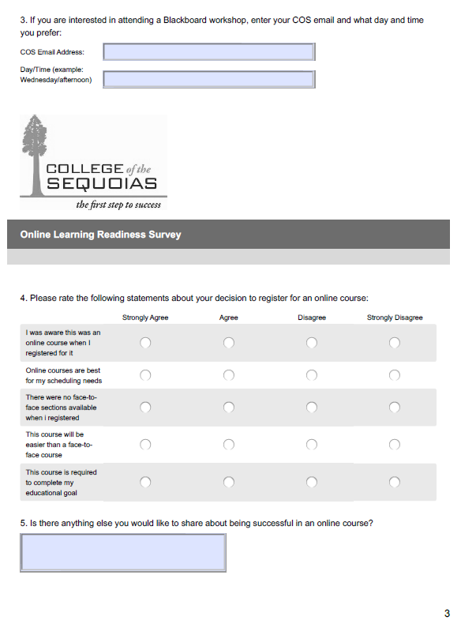

Appendix J: Online Success Survey
